Job Description
NHS Professionals Limited

Job Title: | Flexible Worker Advisor (FWA)
Grade: | L1
Location: | Local Client Services Team - NHS client on-site

Role:

Berkshire Healthcare NHS Foundation Trust provides a wide range of mental health and community health services for people of all ages across Berkshire. With around 5,000 staff working in hospitals, clinics, and community settings, the Trust aims to deliver high-quality, person-centred care close to home. Berkshire Healthcare is rated “Outstanding” by the Care Quality Commission (CQC).

This critical role for NHS Professionals (NHSP) supports Berkshire Healthcare NHS Foundation Trust by providing on-site customer support to NHSP Bank Members. You will ensure that all contact with NHSP is quick, simple, and helpful. Bank Members will look to the Flexible Worker Advisor (FWA) for expert advice and guidance, and will expect prompt, effective resolution of any enquiries that cannot be addressed by the NHSP National Service Centre. You will primarily be based in Bracknell but may be required to travel to other Berkshire Healthcare locations on an ad hoc basis.

The aim of the on-site team is to facilitate the filling of bank shifts while ensuring that Bank Members’ requirements are consistently met or exceeded. Success in this role relies on building strong working relationships with both hiring managers and Bank Members and proactively addressing potential process or service issues to prevent escalation. The ultimate goal is to deliver an exceptional customer experience, reflecting our commitment to being a truly “customer-obsessed” organisation.

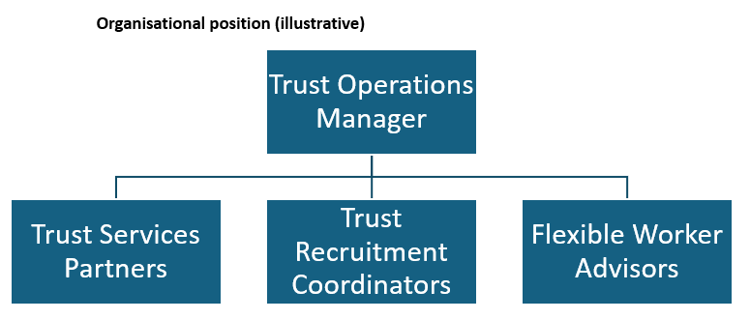

Responsibilities:
- Develop and maintain a strong working knowledge of both NHS Professionals (NHSP) and Berkshire Healthcare NHS Foundation Trust.
- Identify, establish, and build relationships with key NHSP Centre colleagues responsible for the remote delivery of services to your customers.
- Deliver and promote the high standards of NHSP to existing and potential Bank Members, acting as an NHSP ambassador at all times.
- In collaboration with the Trust Recruitment Coordinator, support the recruitment of new Bank Members by explaining the process and, where needed, guiding them from application through to their first shift.
- Validate, sign off, and record Bank Member documentation associated with Right to Work and DBS checks, adhering to current legislation and best practice, and working closely with the central compliance team.
- Build trust and maintain strong, ongoing relationships with the Bank Member community.
- Act as the first point of contact for all Bank Member queries—whether face to face, by phone, or by email—ensuring each query is logged and resolved promptly, in line with agreed SLAs.
- Escalate any service issues to the Trust Services Partner, Operations Manager, and/or Client Account Manager as appropriate.
- Support Bank Members (and, when required, hiring managers) through the booking process to ensure it is seamless and provides an excellent experience.
- Provide support to hiring managers new to the process with adding, modifying, or removing shifts.
- Proactively engage with Bank Members through new starter calls, first shift reviews, and first pay-day checks.
- Attend worker clinics to address issues and promote a sense of community and ongoing support.
- Support the audit process by collating DBS and Right to Work documentation in collaboration with the Trust Recruitment Coordinator and central compliance team.
- Maintain accurate records of meetings, consultations, and incidents.
- Work collaboratively with central services to ensure the individual needs of flexible workers are met.
- Provide general administrative support to the Trust Services Partner, including running reports and collating flexible worker data.
- Ensure adequate supplies of promotional materials and office resources are maintained.
- Contribute to a positive working environment, ensuring it remains safe, clean, tidy, and welcoming for colleagues and customers.
- Adhere to GDPR legislation and seek guidance promptly if a potential breach is identified.

Occasional responsibilities as and when required
- Support the recruitment, welcome, and induction of new Bank Members in collaboration with the Trust Recruitment Coordinator.
- Provide a flexible, collaborative approach to supporting other NHSP Client Services team members, including covering in their absence, to ensure service standards are maintained. This may include travel to other sites in the region.

Accountabilities:
- Provide first-fix resolution for customer queries, ensuring all enquiries are accurately logged and, if passed on, directed to the correct department and clearly signposted.
- Accurately validate and record Right to Work and DBS documents, ensuring each Bank Member requires only one meeting with the Client Services Team during their application process and that their file passes audit first time.
- Ensure feedback from Bank Members and hiring managers is consistently positive, and that any areas for improvement are identified and addressed as part of the local continuous improvement initiative.
- Respond to all Bank Member and hiring manager contact promptly and effectively, in line with local SLAs.

Key Values:
In addition to undertaking the duties as outlined above, you will be expected to fully adhere to the following:

- Equality and Diversity
To act in accordance with NHS Professional’s Equality and Diversity Policy, this is designed to prevent discrimination of any kind.
- Health and Safety
Ensure that all duties are carried out in line with NHS Professional’s Health and Safety Policy.
- Corporate Image
Adopt a professional image at all times.
- Risk Management
Responsibility for reporting complaints, incidents and near misses through the Complaints and Incidents Management System (CIMS).
Responsibility for attending health and safety training as required. Responsibility for assisting with risk assessments.
- Scheme of Delegation
To comply with the Scheme of Delegation - this requires any employee to declare an interest, direct or in-direct, with contracts involving the organisation.

Note:
This job description outlines the roles, duties and responsibilities of the post. It is not intended to detail all specific tasks.

PERSON SPECIFICATION

CRITERIA: | ESSENTIAL  (When applying for this job it is important you fulfil all these essential requirements. If you do not, you are unlikely to be  interviewed) | DESIRABLE  (When applying for this job it is desirable you fulfil these requirements. However, if you do not you may still apply and may be  interviewed) |  | HOW  IDENTIFIED  A / C / I / P / R /  T
Qualifications & Knowledge: | • GCSE Maths and English at Grade C or above or equivalent qualification/level of experience. | - Qualified to NVQ Level  3 in Business.  Administration/Office Practice.  - Evidence of Customer  Service Skills Training. |  | A/C/I
Experience: | - Customer service or retail in an environment where delighting the customer is the core focus.  - Administration experience.  - Ability to handle a high volume internal and external customer enquiries and manage conflicting priorities. | - Face to face customer  Service.  - Previous experience of working in a demanding customer  focused environment. |  | A/I/T
Communication &  People Skills: | - Advanced ability to connect and communicate effectively in writing, face-to-face and over the telephone with a wide range of customers.  - Proactive approach to relationships and troubleshooting.  - Ability to recognise own limitations and escalate issues appropriately.  - Conflict management.  - Problem solving/solution focussed.  - True team player that actively supports all internal colleagues. | • Complaint handling. |  | A/I/T
Organisational  Skills: | - Proficiency in MS Office.  - Record management skills. |  |  | A/I/T
- Ability to manage time and workload effectively.
- Ability to prioritise conflicting workloads.
- Flexible approach to changing business needs.
- Resourceful and solution focussed.
- Punctual, reliable and calm under pressure.
- Exceptional attention to detail.

Specialist  Knowledge/ Skills: |  | •  • | NHS sector knowledge and an understanding of healthcare roles and responsibilities.
 |  | • | Pre-employment vetting.
Physical Skills: | - Able to pass pre-employment checks.  - Ability to undertake desk work.  - Ability to visit clients and clinical areas.  - Keyboard skills. |  |  | A/I
Equality: | • Candidates should demonstrate a commitment to the principles underlying NHS Professionals Ltd’s  Equality and Diversity and  Health and Safety Policies.

Key: A = Application Form C = Certificate I = Interview P = Pre-employment health screening R
= References T = Tests/presentation

