Job Description
NHS Professionals Limited

Job Title: | Pay & People Services Business Apprentice
Grade: | Apprenticeship
Location: | Hemel Hempstead

Providing support to the Corporate workforce by delivering efficient, confidential administrative services while upholding professional standards

Organisational Position (Illustrative)

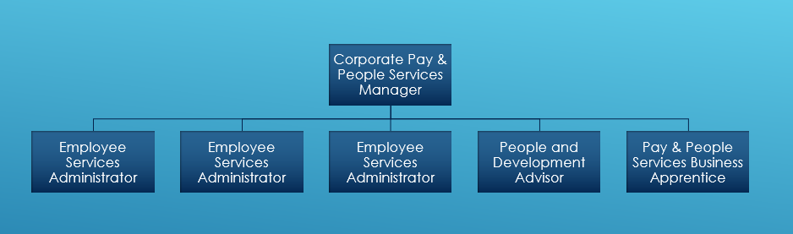

Responsibilities

- To manage Employee Services Service Desk, responding to queries, allocating work to the team in a timely manner.
- Provide efficient and confidential administrative support, including handling general enquiries and establishing and maintaining effective office systems.
- To provide confidential administrative support in terms of dealing with general enquiries, establishing and maintaining office systems.
- Develop a comprehensive understanding of the roles and responsibilities of the Corporate People Team to support the effective handling of emails, correspondence, and enquiries with minimal supervision.
- Provide administrative support, including the production of documents using Microsoft applications such as Word, Excel, Outlook, and PowerPoint.
- To continually review and enhance ways of working by driving continuous improvements to processes and system developments.
- Continually review and enhance ways of working by contributing to continuous improvements in processes and system developments.
- Deliver excellent customer service to Corporate team members via the Employee Services Support Desk.
- Manage filing systems and maintain clear audit trails for all tasks, ensuring compliance with data protection and record-keeping requirements.
- Assist with the collation, analysis, and presentation of information for statistical and management reports as required.
- Support the maintenance and accuracy of HIRS data.
- Take accurate minutes at meetings, including investigation, disciplinary, and appeal meetings.
- Support People Team activities, including tasks, workshops, and team days, as required.
- Provide administrative support for the People Forum and staff networks.

Accountabilities

- To organise and maintain effective administrative procedures including the maintenance and control of documents ensuring they are kept fully up to date and the most current versions are in use.
- Assist in providing advice and guidance to managers and employees on standard HR policies and procedures, and terms and conditions of employment, escalating queries as appropriate.
- Work closely with the Employee Services Team and the wider People Team to deliver excellent customer service and support continuous improvement.
- To process People related paperwork for individual employees as required and ensure accurate and appropriate records are retained in personal files.
- Maintain records, data entry and reporting on People information.
- Effectively prioritising and managing workloads in response to changing service demands.
- Continuously learn the latest People best practices to improve workplace efficiency
- Managing both professional studies and work responsibilities
- Build effective working relationships with key stakeholders through professional and responsive communication
- Comply with all organisational policies, procedures, and statutory requirements relevant to the role.

Key Values:

In addition to undertaking the duties as outlined above, the job holder will be expected to fully adhere to the following:

- Equality and Diversity
To act in accordance with NHS Professional’s Equality and Diversity Policy, this is designed to prevent discrimination of any kind.
  - Health and Safety
Ensure that all duties are carried out in line with NHS Professional’s Health and Safety Policy.
    - Corporate Image
Adopt a professional image at all times.
- Risk Management
Responsibility for reporting complaints, incidents and near misses through the Complaints and Incidents Management System (CIMS)
Responsibility for attending health and safety training as required.
Responsibility for assisting with risk assessments.
- Scheme of Delegation
To comply with the Scheme of Delegation - this requires any employee to declare an interest, direct or in-direct, with contracts involving the organisation.

Note:

This job description outlines the roles, duties and responsibilities of the post. It is not intended to detail all specific tasks.

PERSON SPECIFICATION

CRITERIA: | ESSENTIAL  (When applying for this job it is important you fulfil all these essential requirements. If you do not you are unlikely to be interviewed) | DESIRABLE  (When applying for this job it is desirable you fulfil these requirements. However, if you do not you may still apply and may be interviewed) | HOW IDENTIFIED  A / C / I / P / R / T
Qualifications & Knowledge: | - 5 GCSE or equivalent including English and Math’s.  - Certificate in Personnel Practice or equivalent  - Excellent knowledge of Microsoft applications including, Word, Excel, PowerPoint  - Willing to undertake relevant Personal Development. | - Working towards a Certificate in Personnel and Development (CIPD) or equivalent | A / C / T
Experience: | - Sufficient experience providing administrative support to a team  - Experience of working in an HR environment  - Demonstrable experience as either a secretary or as a departmental administrator  - Excellent key board skills  - Experience of preparing letters, reports and presentations.  - Experience of providing support on HR Issues  - Experience of attending meetings, taking minutes and distributing within appropriate time scales. | - Previous NHS experience  - Experience of using the Electronic Staffing Records System | A / I / T
Communication & People Skills: | - Confident communicator with excellent telephone manner  - Excellent written communication skills in order to write well-structured letters and Master documents to be used by the HR Team  - Personal drive for high work standards/excellence.  - Ability to work as part of a Team and provide consistent support  - Use own initiative? |  | A / I / R
Organisational Skills: | - Proven organisational skills  - Good time management skills.  - Able to anticipate needs and requirements  - Excellent prioritising skills and ability to be flexible in order to support a  - team with changing priorities  - Able to deal with changing volumes of workloads  - Thorough and methodical.  - Accurate  - Able to work in a busy environment and work to tight deadlines. |  | I
Specialist Knowledge/ Skills: | - Attention to detail and high standards of accuracy  - Supportive, flexible, adaptable and reliable  - Able to use own initiative  - Team worker  - Understanding of need for confidentiality and ability to work with confidential data in a professional manner.  - Basic knowledge of employment law, recruitment processes and best practice in Human Resource Management  - Ability to work with a number of projects simultaneously  - Able to use own initiative  - Confidential and pro-active approach to work  - Ability to work with sensitive and complex information as required | - Knowledge of current NHS Policies  - Knowledge of and ability to use HR Databases. | I / T
Physical Skills: | - Normal office work requirements  - Able to pass NHSP pre-employment checks |  | P
Equality: | - Evidence of having worked within environments where equality and diversity are critical  - Candidates should indicate an acceptance of and commitment to the principles underlying Equality and Diversity and Health and Safety Policies. |  | I

Key: A = Application Form C = Certificate I = Interview P = Pre-employment health screening R = References T = Tests/presentation

