Job Description
NHS Professionals Limited

Job Title: | Corporate Reward & People Analytics Apprentice
Grade: | Apprenticeship
Location: | Hemel Hempstead

Providing support to the corporate workforce by delivering efficient, confidential and analytics services while upholding professional standards.

Organisational Position (Illustrative)

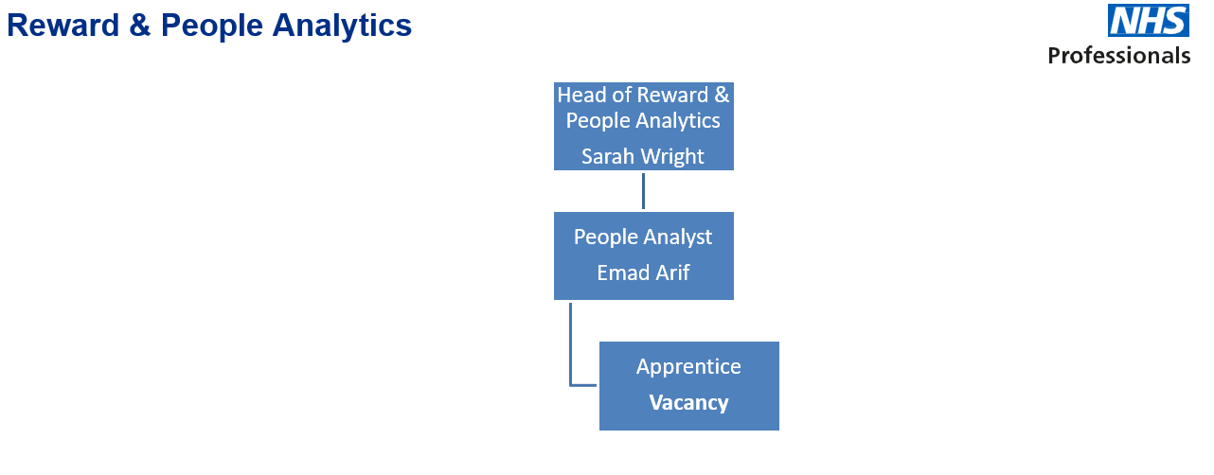

Responsibilities

- Help build and maintain a secure, sustainable database solution in partnership with IT and stakeholders which aligns with our existing ecosystem.
- Provide confidential analytics support to People Analyst in dealing with data queries, building and maintaining Data Lake (Data Warehouse).
- Provide confidential analytics support for wider NHSP and People Team.
- To maintain and suggest new data builds using Excel, Power BI and Office 365 tools.
- Develop a comprehensive understanding of the roles and responsibilities of the Corporate People Team and People Analytics.
- Provide administrative support, including the production of documents using Microsoft applications such as Word, Excel, Outlook, and PowerPoint.
- To continually review and enhance ways of working by driving continuous improvements to processes and system developments.
- Ability to present complex data clearly and concisely to non-technical stakeholders, both verbally and in writing.
- Manage filing systems and maintain clear audit trails for all tasks, ensuring compliance with data protection and record-keeping requirements.
- Maintain Access Audit to all dashboards and give or revoke access to dashboards when no longer required.
- Assist with the collation, analysis, and presentation of information for statistical and management reports as required.
- Support the maintenance and accuracy of HR data.
- Able to take notes at meetings with high accuracy and translate those into insights for People Analyst and Head of Reward & People Analytics.
- Support People Team activities, including tasks, workshops, and team days, as required.
- Maintain records and update data entries for reporting on People Function.
- Determination and tenacity to overcome challenges and deliver impactful solutions.

Accountabilities

- Manage both professional studies and work responsibilities.
- Build effective working relationships with Key stakeholders through professional and responsive communication.
- Effectively prioritise work and manage workloads in response to changing service demands.
- Maintain a good working relationship with wider NHSP and People Team.
- Effectively communicate and address any issues with Data or Data accuracy in a timely manner.
- Comply with all organisational policies, procedures, and statutory requirements relevant to the role.

Key Values:

In addition to undertaking the duties as outlined above, the job holder will be expected to fully adhere to the following:

- Equality and Diversity
To act in accordance with NHS Professional’s Equality and Diversity Policy, this is designed to prevent discrimination of any kind.
  - Health and Safety
Ensure that all duties are carried out in line with NHS Professional’s Health and Safety Policy.
    - Corporate Image
Always adopt a professional image.
- Risk Management
Responsibility for reporting complaints, incidents and near misses through the Complaints and Incidents Management System (CIMS)
Responsibility for attending health and safety training as required.
Responsibility for assisting with risk assessments.
- Scheme of Delegation
To comply with the Scheme of Delegation - this requires any employee to declare an interest, direct or in-direct, with contracts involving the organisation.

Note:

This job description outlines the roles, duties and responsibilities of the post. It is not intended to detail all specific tasks.

PERSON SPECIFICATION

CRITERIA: | ESSENTIAL  (When applying for this job it is important you fulfil all these essential requirements. If you do not you are unlikely to be interviewed) | DESIRABLE  (When applying for this job it is desirable you fulfil these requirements. However, if you do not you may still apply and may be interviewed) | HOW IDENTIFIED  A / C / I / P / R / T
Qualifications & Knowledge: | - 5 GCSE or equivalent including English and Math’s.  - Certificate in Personnel Practice or equivalent.  - Excellent knowledge of Microsoft applications including Word, Excel and PowerPoint.  - Willing to undertake relevant Personal Development. | - Working towards a Certificate in Personnel and Development (CIPD) or equivalent. | A / C / T
Experience: | - Sufficient experience providing analytics support to a team.  - Experience of working in an HR environment.  - Demonstrable experience for a Data Entry role.  - Experience of preparing professional emails, reports and presentations using PowerPoint.  - Experience of attending meetings, taking minutes and distributing within appropriate time scales.  - Experience in the use of data tools such as Excel, Power BI etc to support accurate data entry, analysis, and reporting.  - Experience in using Microsoft 365 tools such as Outlook, OneDrive, SharePoint etc. | - Experience of using the Electronic Staffing Records System.  - Experience in Other BI tools such as Tableau, Databricks etc. | A / I / T
Communication & People Skills: | - Confident and effective communicator with strong written communication skills, including the ability to produce clear and professional emails.  - Personal drive for high work standards/excellence.  - Ability to work as part of a Team and provide consistent support.  - Use own initiative on tasks  - Demonstrate the ability to prioritise work effectively and meet required deadlines |  | A / I / R
Organisational Skills: | - Proven organisational skills.  - Good time management skills.  - Able to anticipate needs and requirements.  - Excellent prioritising skills and ability to be flexible to support a team with changing priorities.  - Able to deal with changing volumes of workload.  - Thorough and methodical and accurate.  - Able to work in a busy environment and work to tight deadlines. |  | I
Specialist Knowledge/ Skills: | - Attention to detail and high standards of accuracy.  - Highly attentive towards Data Accuracy.  - Excellent in Data entry.  - Confident in working with large datasets.  - Supportive, flexible, adaptable and reliable.  - Able to use own initiative.  - Understanding of need for confidentiality and ability to work with confidential data in a professional manner.  - Basic knowledge of employment law, recruitment processes and best practice in Human Resource Management  - Ability to work with several projects simultaneously.  - Confidential and pro-active approach to work.  - Ability to work with sensitive and complex Datasets.  - Knowledge of and ability to use HR Databases. | - Experience in Data Visualisation.  - Experience in Data Modelling. | I / T
Physical Skills: | - Normal office work requirements  - Able to pass NHSP pre-employment checks |  | P
Equality: | - Evidence of having worked within environments where equality and diversity are critical  - Candidates should indicate an acceptance of and commitment to the principles underlying Equality and Diversity and Health and Safety Policies. |  | I

Key: A = Application Form C = Certificate I = Interview P = Pre-employment health screening R = References T = Tests/presentation

