**Job Description**

**NHS Professionals Ltd**

|  |  |
| --- | --- |
| **Job Title Supplier Relationship Lead** |  |
| **Grade TBC** |  |
| **Location Hemel/Leeds/Agile** |  |

**Role**

As a Supplier Relationship Lead for NHSP you will be responsible for developing deep relationships with our strategic suppliers. The person appointed will be part of the Procurement team and will be responsible for maximising the value and Supplier effectiveness from a portfolio of Supplier relationships from a cost, SLA, support and performance perspective.

**Organisational Structure**

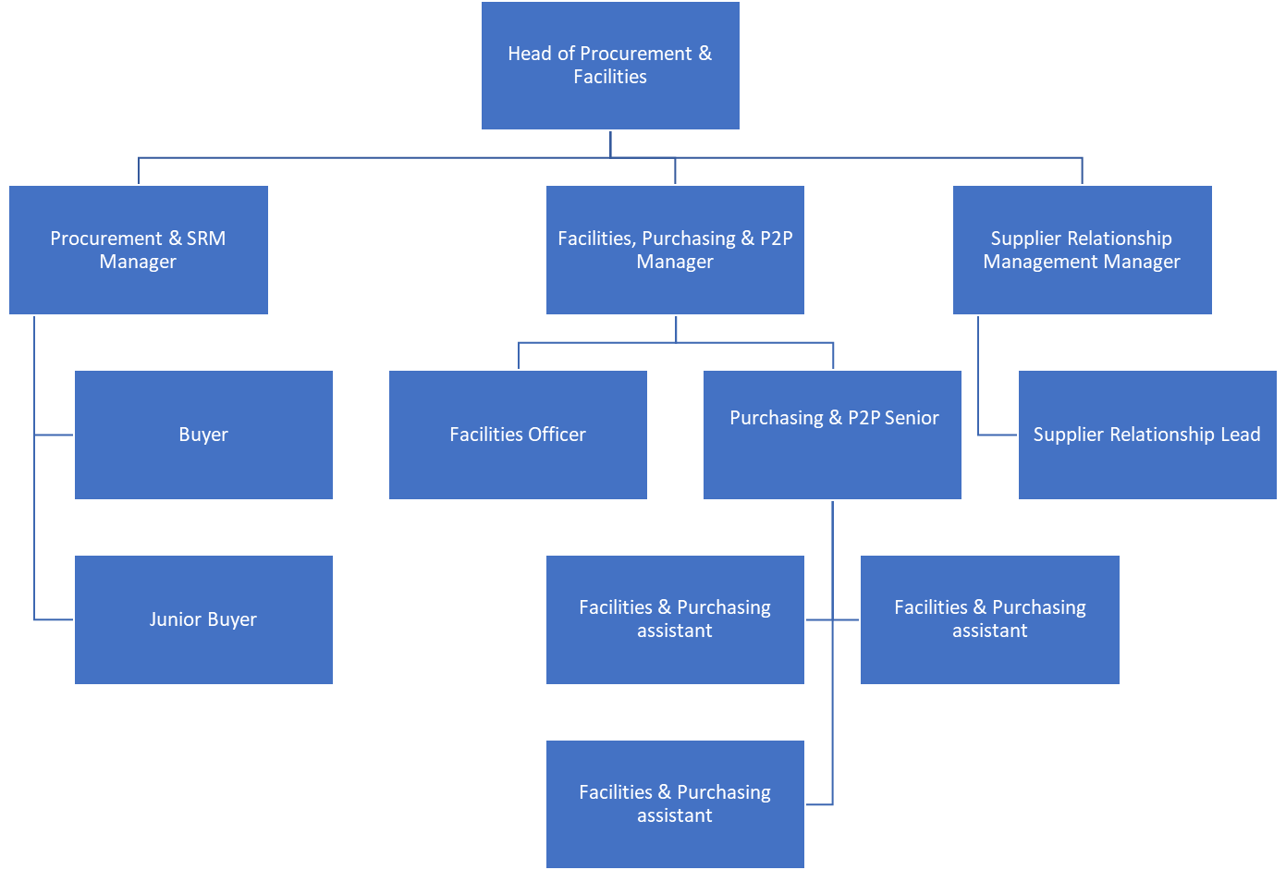

**Responsibilities**

Partnering with the Business to oversee supplier service contracts, ensuring continued high levels of value and quality in service delivery and compliance with SLAs.

Acting as an Escalation point for the Business and Supplier in the event of concerns, ensuring coordination of resolving parties, effective communication to stakeholders and post incident review

Undertaking assurance activities to ensure all controls, processes, documentation and procedures are reviewed regularly and adhered to.

Driving internal and third-party service review meetings covering performance, service improvements, quality and processes

Supporting the Supplier and Business in the agreement and oversight of Service Improvement Plans.

Ensuring actions are followed through to completion in a timely manner

Embedding Supplier relationship Management processes across the Business whilst being recognised as the subject matter expert

Managing contracts in a professional, proactive and commercially focused manner as an integral part of the day to day delivery of Business services.

In conjunction with Procurement, carry out on-going reviews of supplier contracts to maximise contract benefit and optimise contract costs in a targeted fashion.

**Accountabilities**

Support the Supplier Relationship Manager as required

Passion of supporting change in a corporate environment and with individuals.

A continuous improvement approach and mind-set.

A demonstrably strong interpersonal and written communication style.

Ability to manage stakeholders, colleagues, and managing upwards.

Proactive attitude with the ability to be a team player and ability to build strong partnerships with the Business and Suppliers to drive value

An ability to work autonomously and considered a “safe pair of hands”.

Comfortable working in fast paced environment with a capability to prioritise competing demands.

**Key Values:**

In addition to undertaking the duties as outlined above, the job holder will be expected to fully adhere to the following:

* **Equality and Diversity**

To act in accordance with NHS Professionals’ Equality and Diversity Policy - this is designed to prevent discrimination of any kind.

* + **Health and Safety**

Ensure that all duties are carried out in line with NHS Professionals’ Health and Safety Policy.

* + - **Corporate Image**

Adopt a professional image at all times.

* **Risk Management**

Responsibility for reporting complaints, incidents and near misses through the Complaints and Incidents Management System (CIMS)

Responsibility for attending health and safety training as required.

Responsibility for assisting in risk assessments.

* **Scheme of Delegation**

To comply with the Scheme of Delegation this requires any employee to declare an interest, direct or in-direct, with contracts involving the organisation.

**Note:**

This job description outlines the roles, duties and responsibilities of the post. It is not intended to detail all specific tasks.

|  |  |  |  |  |
| --- | --- | --- | --- | --- |
| **PERSON SPECIFICATION** | | | | |
| **Criteria:** | **ESSENTIAL**  *(When applying for this job it is important you fulfil all these essential requirements. If you do not you are unlikely to be interviewed)* | **HOW IDENTIFIED**  A / C / I / P/ R / T | **DESIRABLE**  *(When applying for this job it is desirable you fulfil these requirements. However, if you do not you may still apply and may be interviewed***)** | **HOW IDENTIFIED**  A / C / I / P / R / T |
| **Qualifications and Knowledge:** | Recruitment sector knowledge | A |  |  |
| **Experience:** | Demonstrable experience of effective contract, commercial, service management within a complex multi-source service / supplier environment, including performance/SLA/KPI management, skills/dispute management | P | Service specific contract drafting & negotiation  Risk Management  Ability to analyse complex performance information & invoicing for all outsourced services.  Knowledge of working with and managing outsourced IT Service Providers. | P |
| **Communication and People Skills:** | Excellent written and verbal communications skills | P |  |  |
| **Organisational Skills** | Ability to manage own time and prioritise competing pressures form the business | P |  |  |
| **Specialist Knowledge and Skills** | Experience of Recruitment market | A |  |  |
| **Physical Skills:** | * Must pass pre-employment health assessment. | P |  |  |
| **Equality:** | * Candidates should indicate an acceptance of and commitment to the principles underlying NHSP’s Equality and Diversity and Health and Safety Policies. | I |  |  |

Key: A = Application Form C = Certificate I = Interview P = Pre-employment health screening R = References T = Tests/presentation